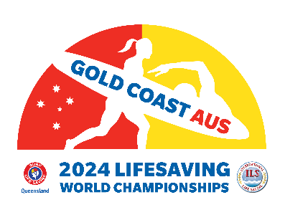
GOLD COAST – AUSTRALIA
20024 LIFESAVING WORLD CHAMPIONSHIPS - ILS MEETINGS
20 AUGUST - 8 SEPTEMBER 2024

Request for an Invitation Letter as support to obtain a visa to enter Australia

Date: (22/03 /2024)

Please provide an official invitation letter for:

First Name (as on your passport)
Family Name (as on your passport)
Date of Birth (DD/MM/YYY)
Place of Birth (city)
Country of Birth
Nationality
Country/City where you will apply for the visa
Passport - Number
Passport - Date of issue
Passport - Date of expiry
Telephone number
Name of Federation
Planned arrival date in Australia
Planned departure date from Australia
Planned accommodation address in Australia

Tick the appropriate box
What | Yes | No
I will participate in the ILS Meetings

I will participate in the 2024 Lifesaving World Championships

Tick the appropriate box
What | Yes | No
I confirm that my federation is funding my travel and accommodation expenses.

I confirm that the concerned person is self-funding the travel and accommodation expenses.

I send this form in Word format to the ILS Headquarters (hq@ilsf.org) and attach to this request form a copy of my passport.

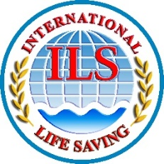
Privacy and Data Protection
I understand and agree that the information I have provided is necessary for the legitimate interests of the International Life Saving Federation (ILS) and its management and administration. The collected information is subject to the ILS Privacy Policy available on the ILS website at https://www.ilsf.org/about/policies/ which I have read. I understand that the ILS will not share my personal data with other organisations for any other purpose than that for which the data was collected, including to verify eligibility, to communicate with and to inform about the activities of the organisation and in connection with the administration of its events and that the ILS Privacy Policy sets out my rights, including the right to withdraw my consent, in connection with the use of my personal data.

